Lesson 8 Trading standards

fit [fɪt] adj. 适合的

fit adj. of a good enough standard for sb. or sth. 适合的

be fit for … be fit to do … The food is not fit for human consumption.

He is not fit to govern this country. suitable

I haven’t any suitable clothes for the wedding.

The present isn’t suitable for an old man. appropriate

Your dress is appropriate for a formal party.

felicitous

felicitous remarks proper

grace [greɪs] v. 使荣耀；装饰，装点

The queen graced us with her presence.

Her face has graced the covers of magazines across the world. graceful

disgrace n. & v. shame humiliate

bring shame / disgrace on … disgraceful

standard ['stændəd] n. 标准，水准，水平

safety / moral / living standards a high / low standard of living

International Standards Organization (ISO) criterion / criteria

admission criterion

the criteria we use to select candidates

yardstick / benchmark

The yardstick / benchmark of truth is practice.

Some people believe that a society has to place its overall success before the well-being of its members to achieve prosperity, whereas others believe that the only benchmark of the well-being of a society is the general welfare of all its people. Admittedly, a society should pursue its overall success, but from my perspective this goal will never be attained unless and until the well-being of all its individual citizens is properly respected.

To sum up, I concede that the overall success of a society is important indeed. However, without sufficient emphasis on personal welfare, not only would the motivations of a society’s citizens be weakened, but the philosophical underpinnings of democracy would also be undermined. Therefore, the only yardstick of the well-being of any society, I believe, is not its overall success, but the general welfare of all its people.

electrocute

[ɪ'lektrəkju:t] v. 电死，以电刑处死

electrocute v. to kill a person or an animal by means of an electric current

execute

execute one’s command / one’s will

= carry out

He was executed for treason. persecute

Jews were persecuted by Nazis. prosecute

Trespassers will be prosecuted.

eliminate [ɪ'lɪmɪneɪt] v. 彻底清除

eliminate v. to completely get rid of sth. that is unnecessary or unwanted

彻底清除

Many infectious diseases have been virtually eliminated. The credit card eliminates the need for cash or checks. remove

get rid of root out

eradicate (“radi”=root radish)

eradicate crime / poverty

abolish

abolish slavery

abolish capital punishment / death penalty

accord [ə'kɔ:d] n. 协议，条约

accord / treaty pact / compact

contract deal

agreement

hammer out ['hæmə aut] v. 敲定了……

hammer out sth

to decide on an agreement, contract etc. after a lot of discussion and disagreement 敲定了……

The two countries finally hammered out an agreement.

reach / come to an agreement keep / honor an agreement break / violate an agreement

trading adj. 贸易的，商业的

trading standards trading partner

The Economist

Chickens slaughtered in the United States, claim officials in Brussels, are not fit to grace European tables. Officials in Brussels claim that chickens slaughtered in the United States are not fit to grace European tables.

‘I’m trying to repair the bell,’ answered Bill. ‘I’ve been coming up here night after night for weeks now. You see, I was hoping to give you a surprise. ’

‘You certainly did give me a surprise!’ said the vicar. ‘You’ve probably woken up everyone in the village as well. Still, I’m glad the bell is working again.’

‘So long as there’s something to identify, we will give people their money back,’ said a spokeswoman for the Bank.‘Last year, we paid $1.5m on 21,000 claims. ’

a local / embassy official official corruption / attitude

bureaucrat bureaucracy

civil servant

Brussels: the capital and largest city in Belgium, centrally situated in northern Europe. Brussels is internationally important as the headquarters of the European Union (EU) and the North Atlantic Treaty

Organization (NATO).

Grand Place

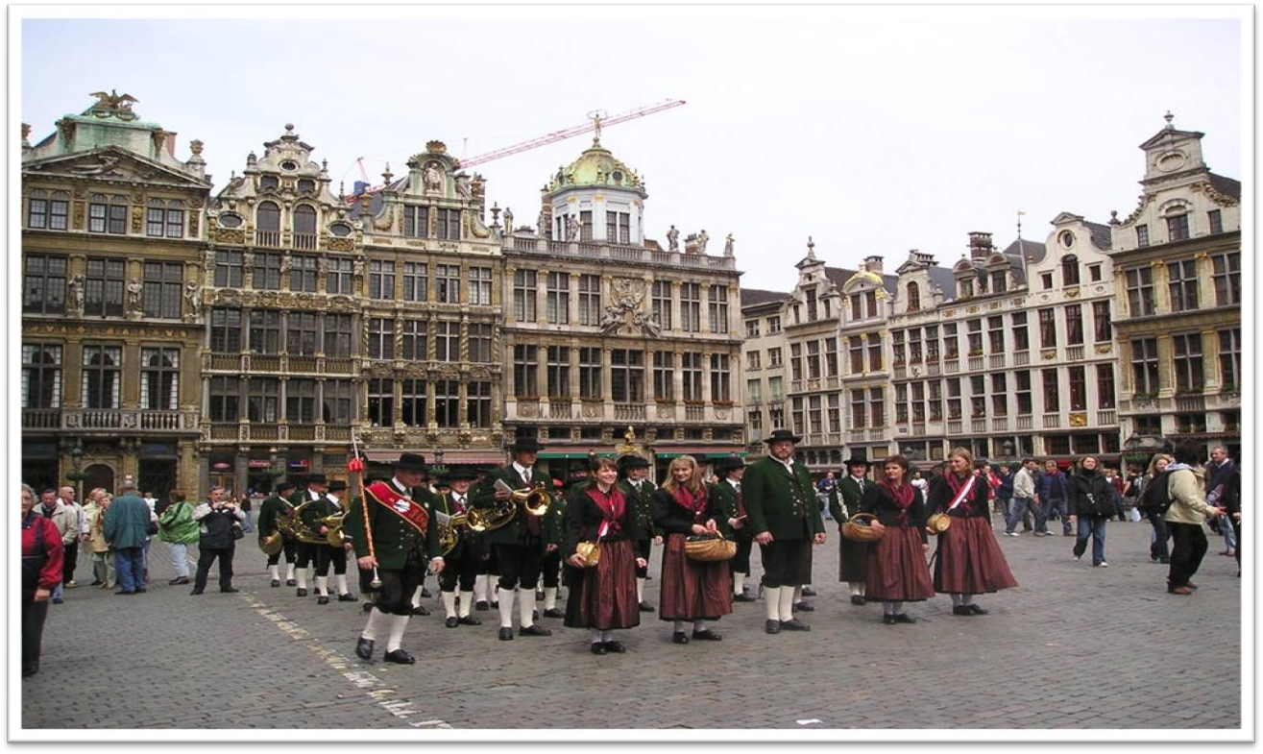

**Manneken Pis**

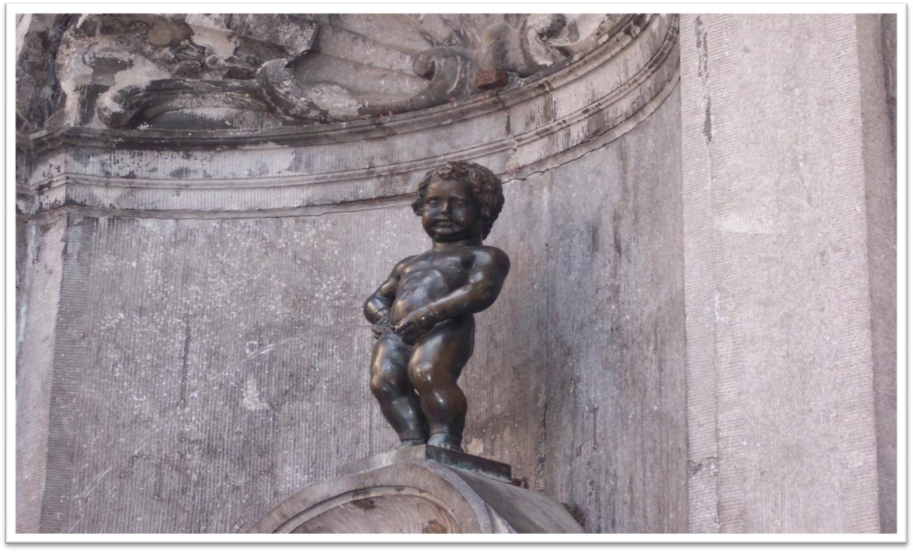

NATO Headquarters

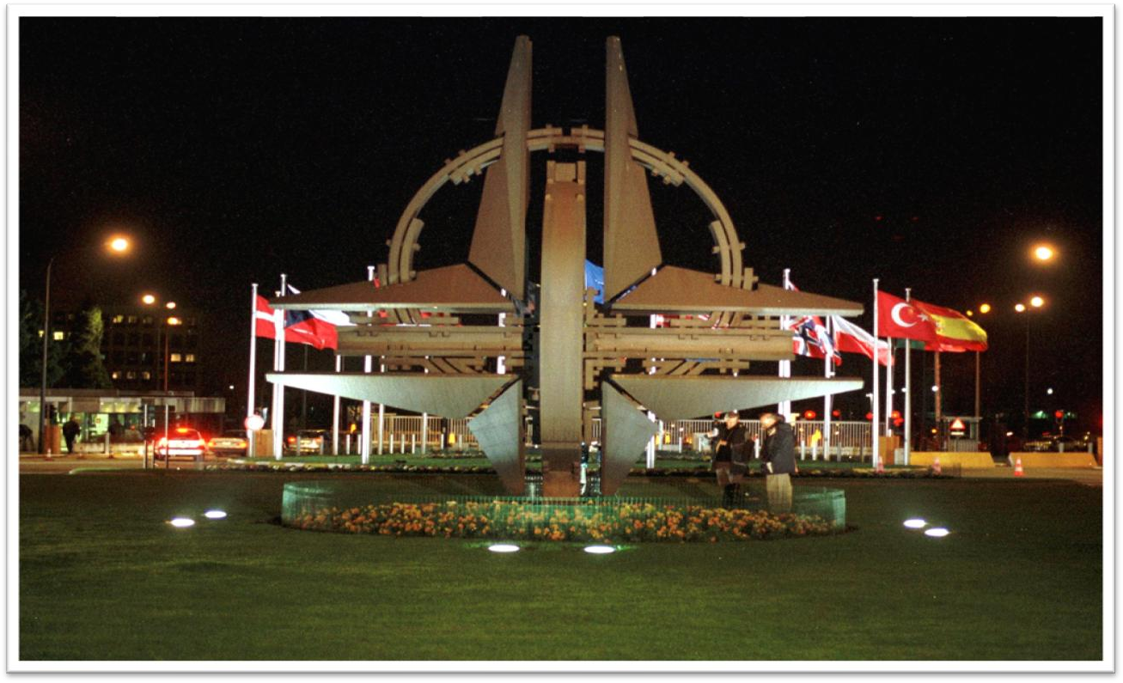

**EU Headquarters**

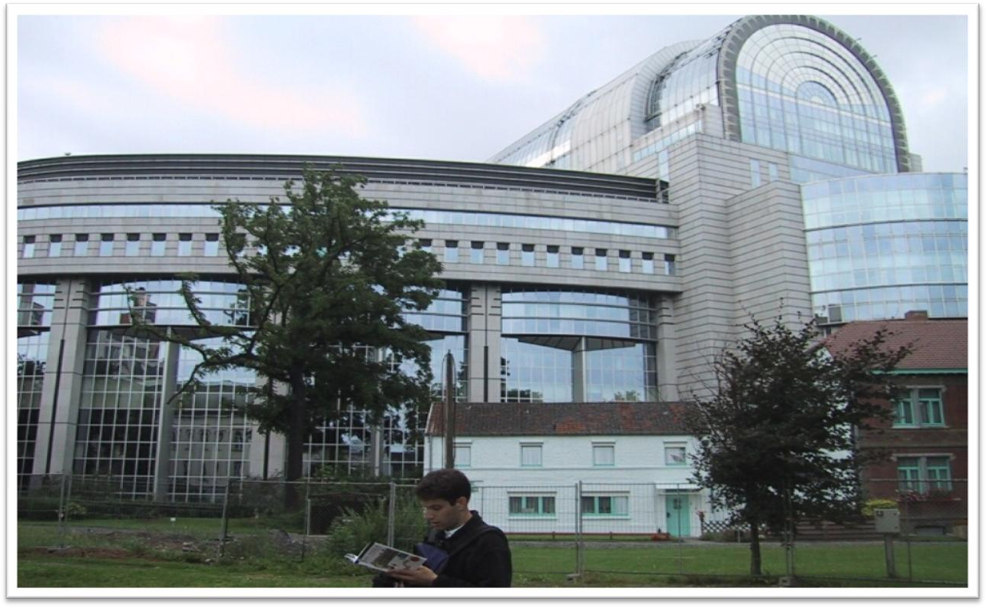

自由直接引语 free direct speech

Chickens slaughtered in the United States are of poor quality.

Chickens slaughtered in the United States don’t meet European standards.

political correctness

sss

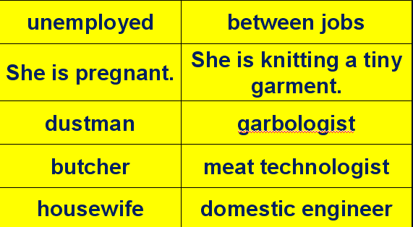

the disabled / handicapped

the physically challenged the mentally challenged the vertically challenged the horizontally challenged

fowl poultry

livestock / stock

These days, it is differences in national regulations, *far more than*

*tariffs*, that put sand in the wheels of trade between rich countries.

these days today nowadays

These days, people who do manual work often receive far more

money than people who work in offices.

in those days

In those days wandering minstrels were welcome everywhere. In those days, boxers fought with bare fists for prize money.

it is / was … that / who … more than sth. 不仅仅是……

Peace is more than the absence of war. more than + adj./adv. 极其/非常…… He is more than selfish.

She can't help the man look for another platter.

She forgot the platter had been broken.

She didn't realize the platter had been broken.

She doesn't want the man to replace the platter.

M: I don’t know how I managed to break that platter. I’ll be *more than* happy to buy you a new one.

W: Forget about it. Some things just can’t be helped. What does the woman mean?

Answer: (D) She doesn't want the man to replace the platter.

I looked into the boy's serious but eager face and asked him, "Do you want any more books?"

"Yes, more than I can ever get," he replied.

more than A can / could …

When my old friend Brian urged me to accept a cigarette, it was more than I could bear.

Dancing proved to be more than the dish could bear, for during the party it capsized and sank in seven feet of water.

The story is more than I can believe.

The beauty of the West Lake is more than words can describe.

Such a complicated situation is far more than we could anticipate and deal with.

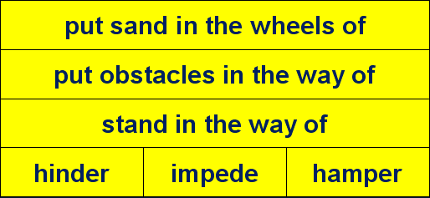

There is none of the hurry which, in our society, often hampers the full development of a growing personality.

造句：现如今，是风俗习惯的差异，而远不仅仅是语言问题，阻碍了跨国婚姻 (transnational marriage)。

These days, it is differences in habits and customs, far more than languages, that put sand in the wheels of transnational marriages.

An electric razor that meets the European Union’s safety standards must be approved by American testers *before it can be sold in the United*

*States*, and an American-made dialysis machine needs the EU’s okay

*before it hits the market in Europe*.

meet

reach pass

live up to satisfy fulfill

... standards

approve vt. to officially accept sth.

The budget has been approved by the legislature.

His application has been rejected. approve of …

Catherine’s parents now approve of her marriage. disapprove of frown on

agreement permission approval

… must be approved by the EU’s testers. hit v. arrive at; reach

… before it can be sold in Europe.

contrast 对照

Men always want to be a woman’s first love; *women have a more*

*subtle instinct: what they like is to be a man’s last romance*. antithesis 对比

There is only one difference between an old man and a young one:

the young man has a glorious future before him and *the old one has a*

*splendid future behind him*: and maybe that is where the rub is.

When poverty comes in at the door, *love leaps out at the window*.A

mother takes twenty years to make a man of her boy, and *another woman*

*takes twenty minutes to make a fool of him*.

as it happen

as luck would have it

He has done a lot of business here in China.

why do

Why worry about such trifles? why not do

Why not try to train your character? lot n. set; collection; group

do v. be enough

Don't you want something to eat?

OK. Two burgers will do.

Politicians agree, in principle, so America and the EU have been trying to reach a deal *which would eliminate the need to double-test many*

*products*.

in principle: if you agree sth. in principle, you agree a general plan or idea but have not yet considered the details

The government has agreed in principle to a referendum.

Although negotiators are optimistic, the details are complex enough

*that they may be hard-pressed to get a deal at all*.

optimistic be optimistic about …

Bankers are cautiously optimistic about the country’s economic future.

optimism optimist

pessimistic be pessimistic about …

He remains deeply pessimistic about the peace process. pessimism

pessimist

The room is large enough to take another bed.

be … enough to do

= be so … as to do

They are rash enough to cross the pass on foot. They are so rash as to cross the pass on foot.

be … enough that …

= be so … that …

be hard-pressed to do sth.

Owing to shortage of staff, the emergency services were hard-pressed to deal with the accident.

construct a sentence construct an agreement

The Americans would happily reach one accord *on standards* for

medical devices and then hammer out different pacts covering, say, electronic goods and drug manufacturing.

The course covers all aspects of business and law. embrace / encompass

The term ‘mankind’ embraces / encompasses men, women, and

children.

In the American economy, the concept of private property embraces not only the ownership of productive resources but also certain rights, including the right to determine the price of a product or to make a free contract with another private individual.

“Anthropology” derives from the Greek words *anthropos* “human” and *logos* “the study of.” By its very name, anthropology encompasses the study of all humankind.

say / let’s say: 假定，比方说

Let’s go out for a walk, (let’s) say, along the river.

The EU—following fine continental traditions—wants agreement on

general principles, *which could be applied to many types of products and*

*perhaps extended to other countries*.

—You wanted me dead, Paul.

—Just following orders.

—Sent me to the chair for sth. I didn’t do, all for your president.

You were willing to do that.

—Just … following … orders.

follow the crowd / herd

follow one’s example / lead

I don’t want you to follow my example / lead and rush into marriage.

continental

a continental climate Continental

the continent / Continent

the channel / Channel

be applied to … extend to …

spread to …